Mock Exams:
For those of you undertaking the full ARTP certification, reporting certification and top up certification you will need to complete a multiple-choice question element. To provide you with practice for this element the ARTP have produced a number of mock multiple-choice questions these can be found on:
https://www.artp.org.uk/MCQ-Bookings

Education for Health – Sample MCQs
In addition to these, we have also included some sample MCQs. If you have any questions or queries regarding the sample MCQs (below) then please request for this support at your monthly tutorials using the following link:
https://forms.office.com/e/pA55FsfE6d

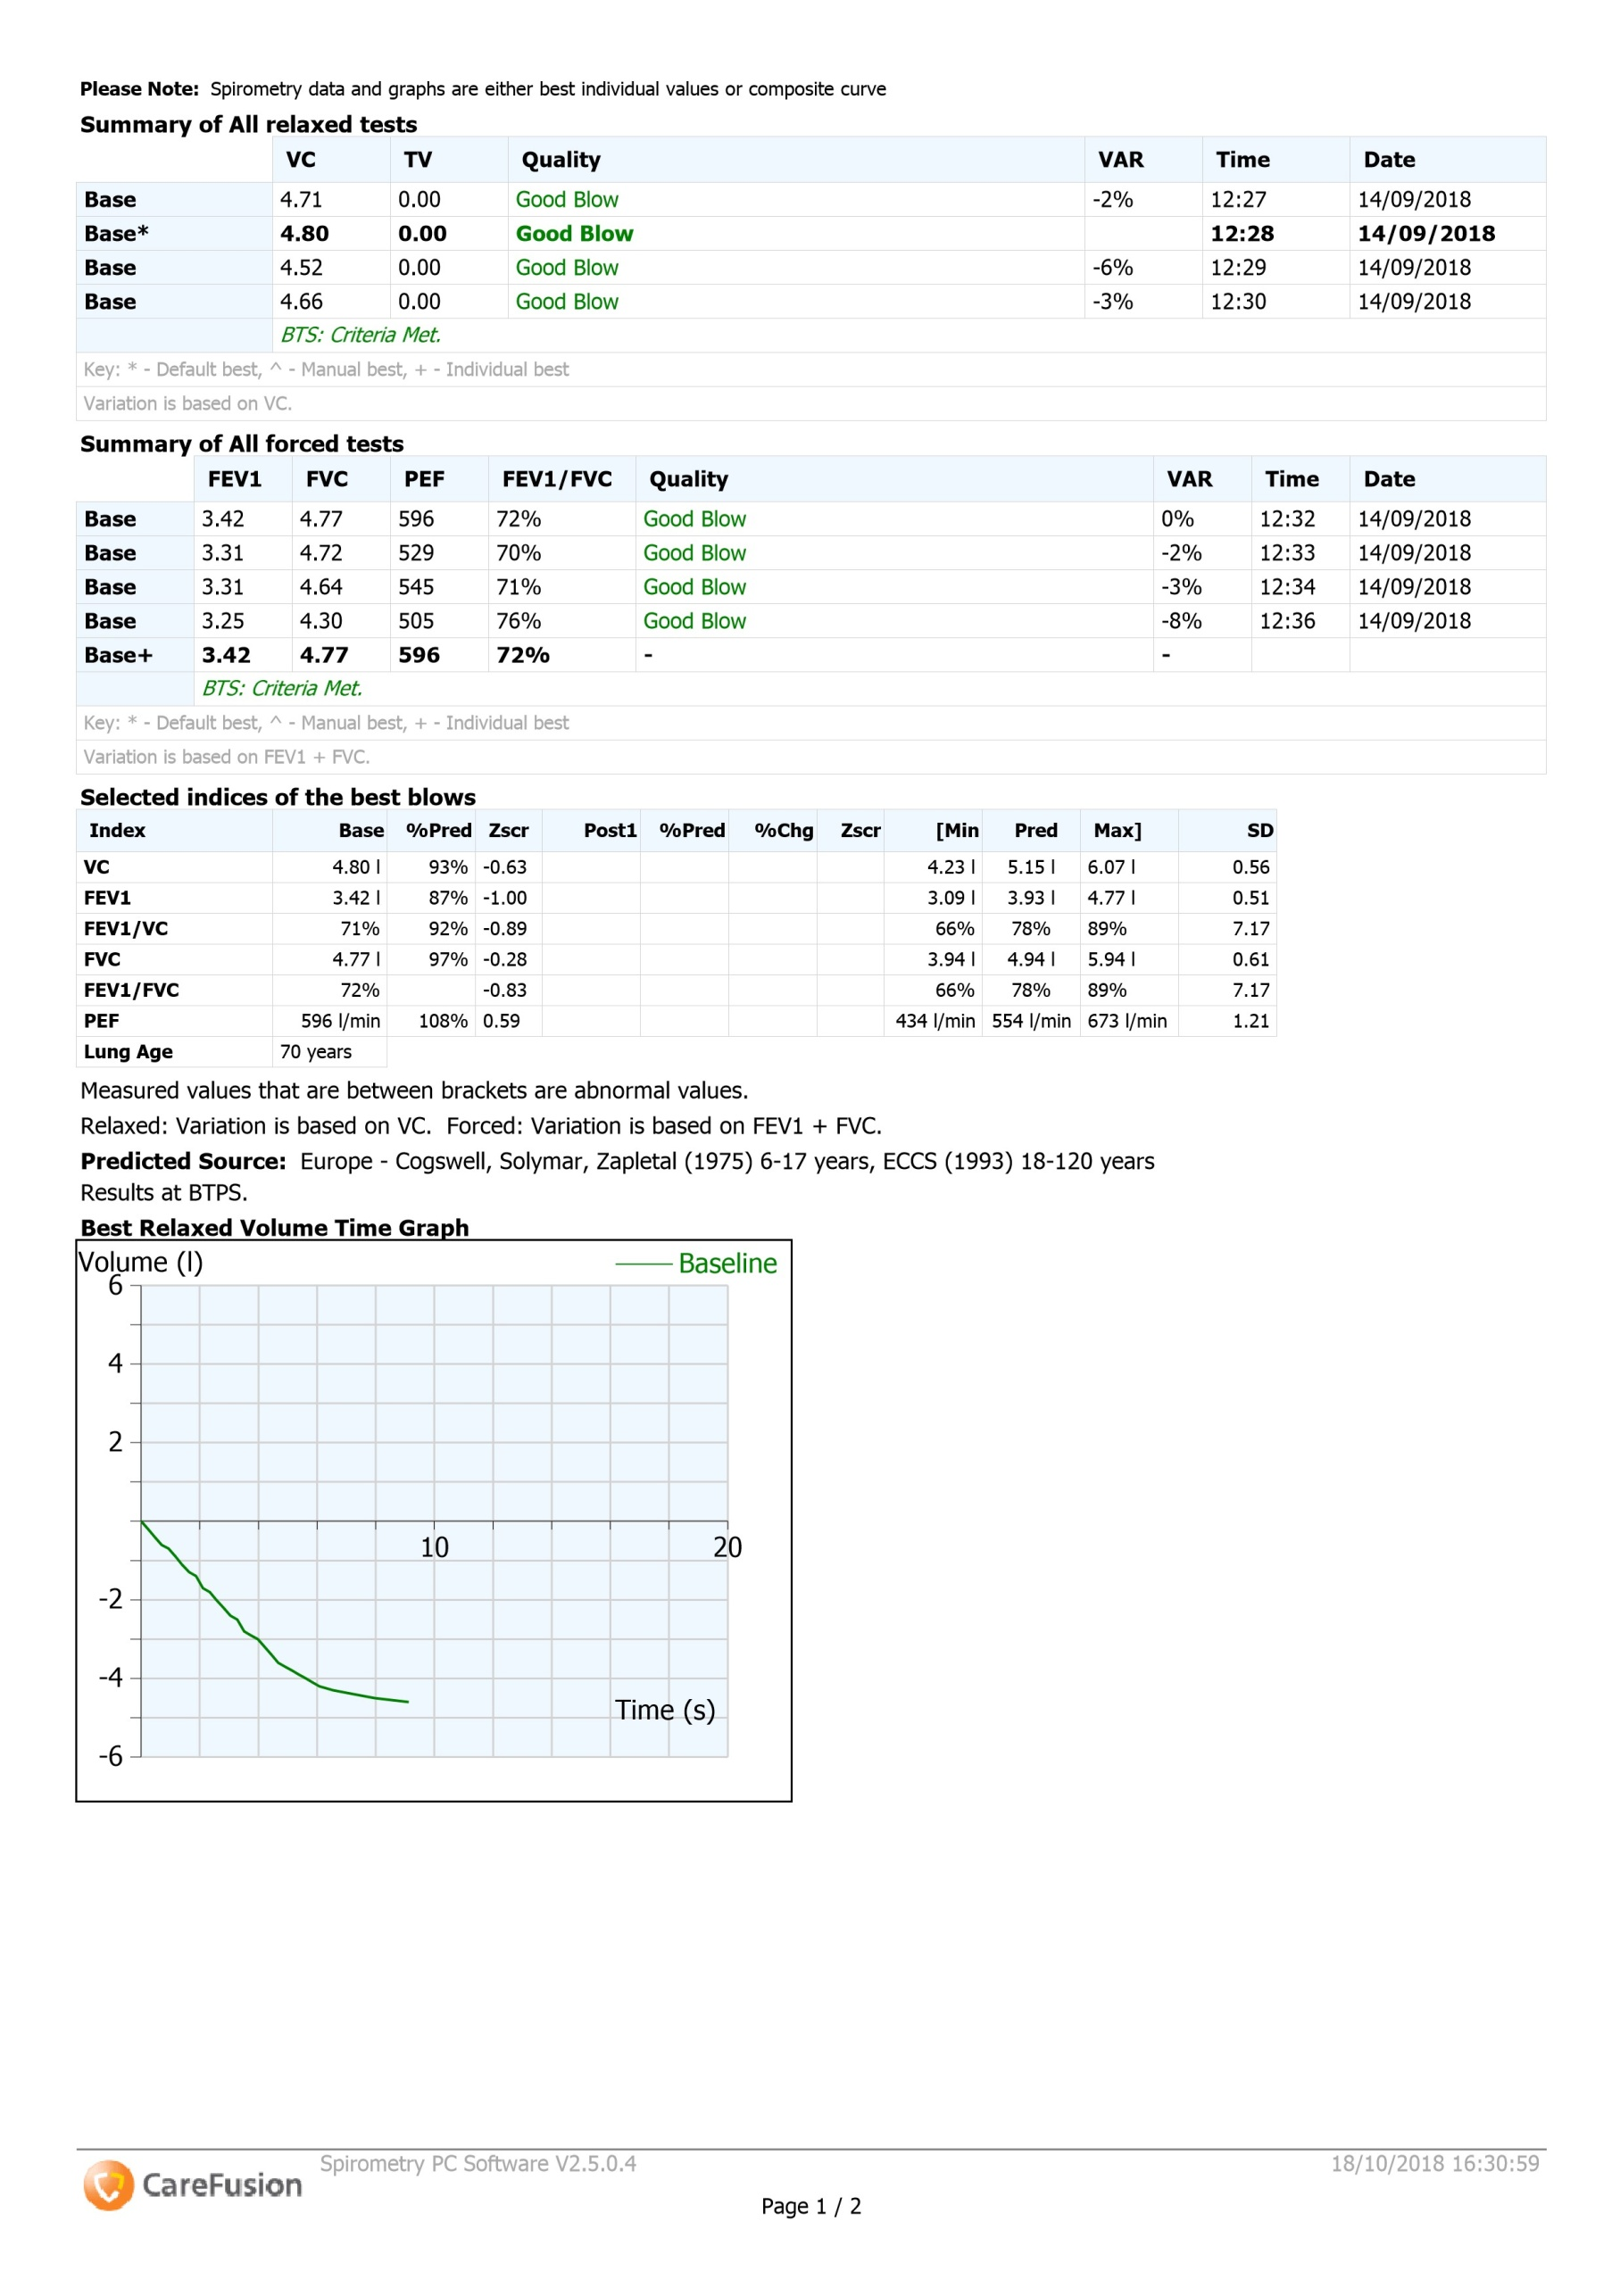
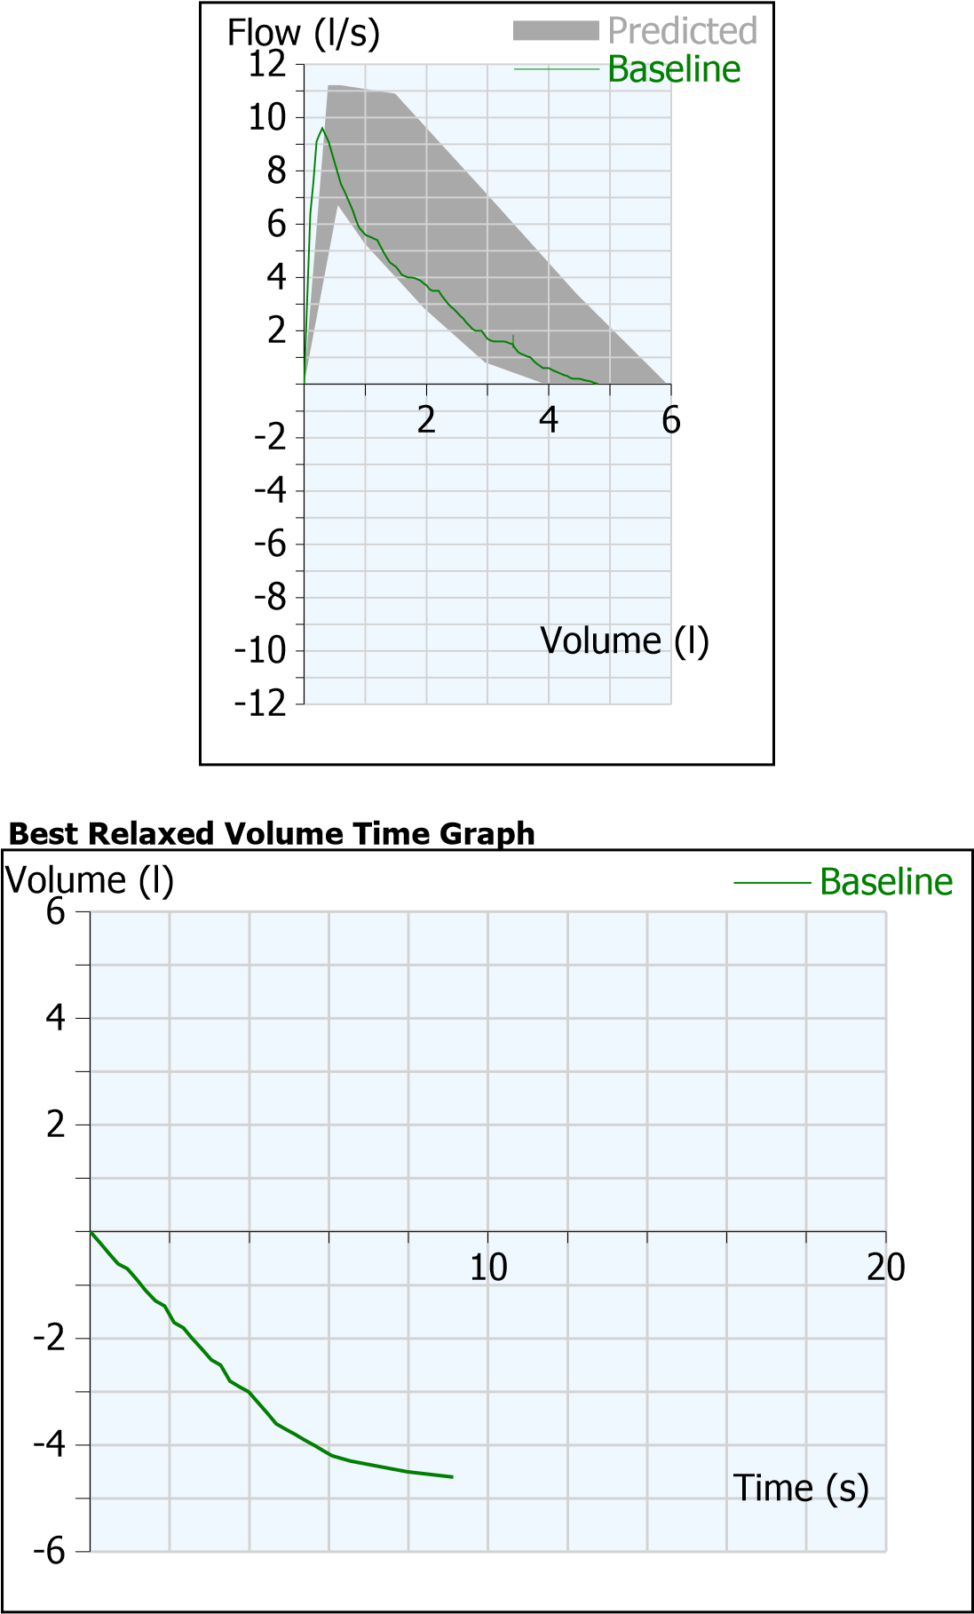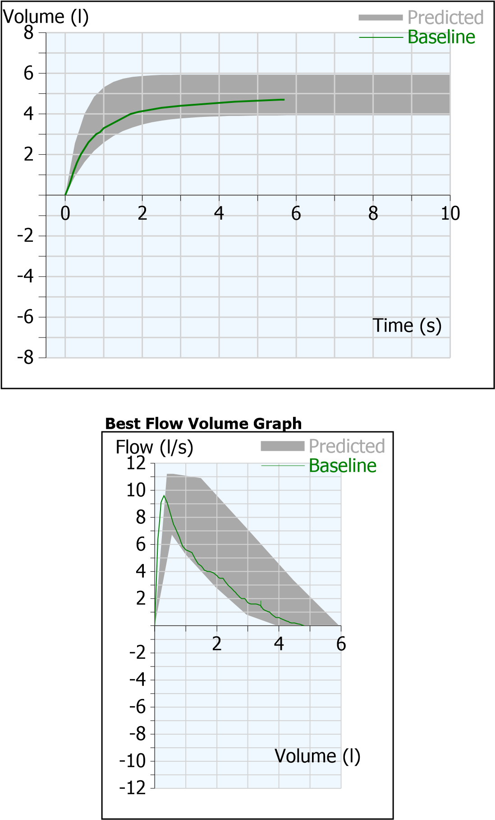

Question 1a:
Using the GLI Reference Equations (2012) and z-score, identify ONE answer below confirming Donnies Spirometry result:
- Obstructive pattern
- Restrictive pattern
- Normal pattern
- Combined pattern (Obstruction with superimposed restriction)

Question 1b:
In reference to the ARTP Statement on Pulmonary Function Testing (2020), identify ONE answer below confirming Donnies peak flow repeatability:
- Peak flow is repeatable because 2 results are within 40L/min
- Peak flow is repeatable because at least 3 results are within 100L/min
- Peak flow is not repeatable because the top 2 results are not within 40L/min
- Peak flow is not repeatable because the top 3 results are not within 40L/min

Question 2.
In reference to the ARTP Statement on Pulmonary Function Testing (2020), which of the following answers are correct? Identify as many as apply.
- The FEV1/FVC ratio must be below the LLN to be classified as obstruction
- Severity grading of moderate would be a z-score of <-2.5
- A positive z-score means the result is below predicted
- Severity grading is based on FEV1 z-score

Question 3a:
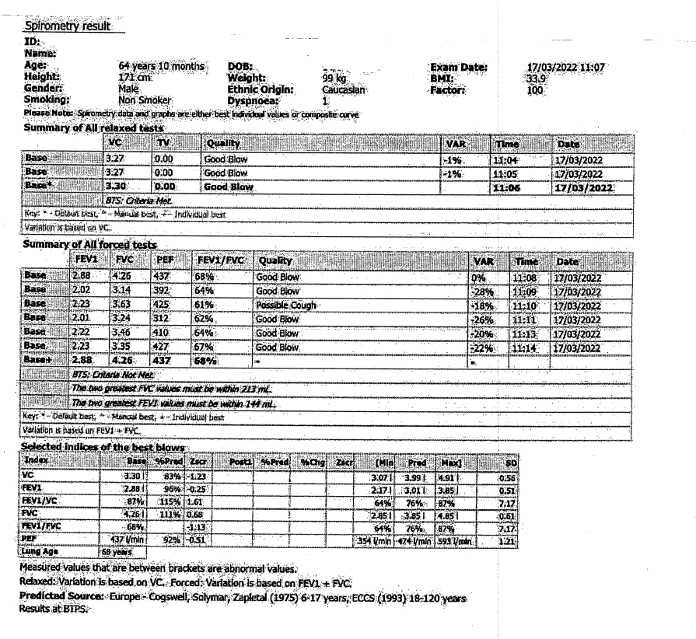
Finlay is 64 years and 10 months old and diagnosed with COPD following a structured clinical history, assessment, and post bronchodilator spirometry. Using the GLI Reference Equations (2012) and z-score, identify ONE answer below confirming Finlay’s Spirometry result:
- Obstructive pattern
- Restrictive pattern
- Normal pattern
- Combined pattern (Obstruction with superimposed restriction)
Question 3b:
Using the GOLD and NICE COPD guidelines, identify from Finlay’s same trace the pattern:
- Obstructive pattern
- Restrictive pattern
- Normal pattern
- Combined pattern (Obstruction with superimposed restriction)

Iain, 32 years and 10 months old, presented with cough and breathlessness with vigorous exercise.
What is the result of this reversibility test? Please select ONE answer
- Positive because it was > 200mls (8%) increase in FEV1
- Negative because it was < 200mls increase in FEV1
- Positive because it was >200mls and an increase of 12% or more
- Negative because it was > 200mls (8%) increase
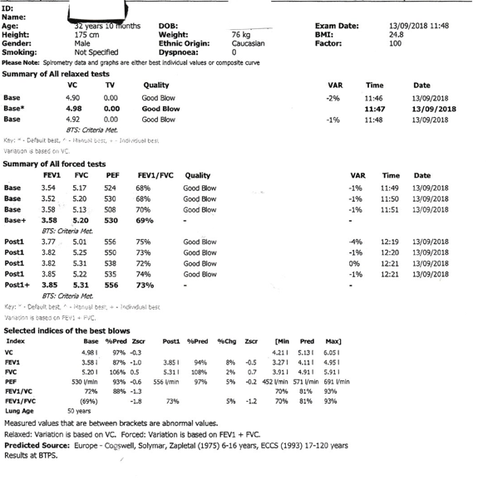

Answers:
Question 1a: C
Question 1b: D
Question 2: A&D
Question 3a: C
Question 3b: A
Question 3b II: D

